1. Log into Blackboard and navigate to the CS553 course.
2. Under Course Content, navigate to Labs, Lab 1
3. Right click on the napkin.txt link and save napikin.txt to your local computer.
4. Open Notepad
5. Select File, Open…
6. Open the nakin.txt file that you saved in step 3.
7. The file should look like this (if it does not then please turn on Word Wrap and press enter to put in some line breaks):

Starbuzz Coffee Beverages

House Blend, $1.49

A smooth, mild blend of coffees from Mexico, Bolivia and Guatemala.

Mocha Cafe Latte, $2.35

Espresso, steamed milk and chocolate syrup.

Cappuccino, $1.89

A mixture of espresso, steamed milk and foam.

Chai Tea, $1.85

A spicy drink made with black tea, spices, milk and honey.

Starbuzz Coffee's Mission To provide all the caffeine that you need to power your life. Just drink it.

1. In Notepad, select File, Save As…
2. Change the filename to napkin.html
3. Change the Save as type to All Files (\*.\*). Note: if the version of Windows you are running does not allow you to change the file type then you will need to save the file as .txt and then rename the file in Windows Explorer.

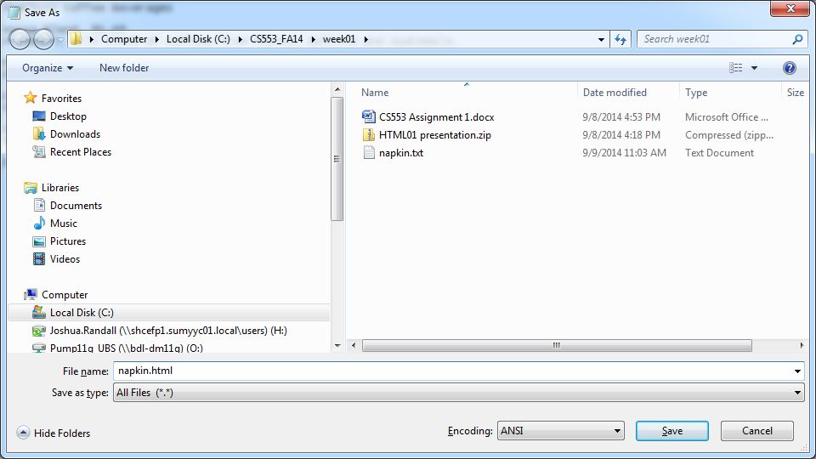

1. Click on Save
2. Open File Explorer
3. Move to the folder where you saved napkin.html
4. Right click on napkin.html, select Open With, and select the web browser of your choice.
5. Return to Notepad and markup napkin.html using the tags shown below.

<html>

<body>

<h1>Starbuzz Coffee Beverages</h1>

<h2>House Blend, $1.49</h2>

<p>A smooth, mild blend of coffees from Mexico,

Bolivia and Guatemala. </p>

<h2>Mocha Cafe Latte, $2.35</h2>

<p>Espresso, steamed milk and chocolate syrup.</p>

<h2>Cappuccino, $1.89</h2>

<p>A mixture of espresso, steamed milk and foam.</p>

<h2>Chai Tea, $1.85</h2>

<p>A spicy drink made with black tea, spices, milk and honey.</p>

Starbuzz Coffee's Mission To provide all the caffeine that you need to power your life. Just drink it.

</body>

</html>

1. In Notepad, select File, Save.
2. Return to the web browser and click on the refresh button. Note how the page has changed.
3. Return to Notepad and enter the style sheet in the head sections that is shown below. It must be added between <html> and <body>.

<head>

<title>Starbuzz Coffee</title>

<style type="text/css">

body {

background-color: #d2b48c;

margin-left: 20%;

margin-right: 20%;

border: 1px dotted gray;

padding: 10px 10px 10px 10px;

font-family: sans-serif;

}

</style>

</head>

1. Return to the web browser and click on the refresh button. Note how the page has changed.
2. Return to Notepad and enter as three separate comments your name, date, and project number. Example:

<!--Josh Randall -->

<!--Jan 10, 2020 -->

<!--Lab 1 -->

1. In Notepad, select File, Save.
2. Return to the web browser and click on the refresh button. Note how the page has changed (or not changed).
3. Open File Explorer
4. Move to the folder where you saved napkin.html.
5. Right click on napkin.html and select Send To.., Compressed (zipped) folder. This will create a .zip file.
6. Open your SHU email and include the .zip as an attachment in an email to randallj@sacredheart.edu.